Car Crash Investigation
By: Stanton Slocum, Claire Shirey, Constance Burton
Incident:
3,000 kg Cadillac Escalade SUV rear-ends a 2,000 kg Subaru Outback Wagon. Once the accident occurred, the Wagon was moved 24 m at $-3 \frac{m}{s^{2}}$ - while the SUV moved 2 m at -2 $\frac{m}{s^{2}}$ away from the contact point. The initial speed of the SUV is undetermined while the wagon was at rest sitting at a stop sign. The team’s job is to determine what happened in the incident and if there were any traffic violations.

- Auto Expert: Research the physics of linear motion and determine, based upon accident site analysis, how fast the SUV and wagon were moving immediately following the collision.
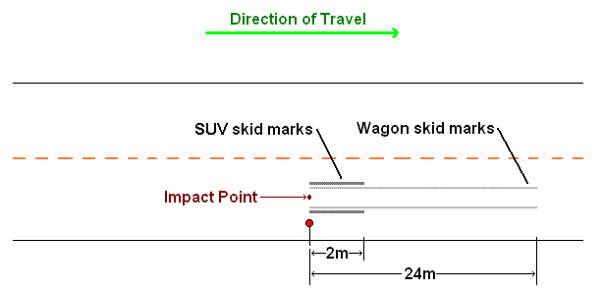
  - The SUV had an acceleration of -${2m/s}^{2}$ and skidded a distance of 2 meters. To find the velocity of the SUV immediately following the collision, use the kinematic equation: $V_{f}^{2}=V_{i}^{2}$+2a∆x
$V_{f}^{2}=V_{i}^{2}$+2a∆x
$0=V_{i}^{2}$+2(-2)(2)
$0=V_{i}^{2}$- 8
$8=V_{i}^{2}$
$2.8m/s=V_{i}$
  - The Wagon had an acceleration of ${-3m/s}^{2}$ and skidded a distance of 24 meters. To find the velocity of the Wagon immediately following the collision, use the same equation as above.
$V_{f}^{2}=V_{i}^{2}$+2a∆x
$0=V_{i}^{2}$+2(-3)(24)
$0=V_{i}^{2}$- 144
$144=V_{i}^{2}$
$V_{i}=12m/s$
  - Immediately following the collision, the SUV had a velocity of 2.8m/s and the Wagon had a velocity of 12m/s. It is unknown whether the accelerations given included frictional forces or not.

- Collision Expert: As the collision expert, I was able to determine how fast the SUV was going prior to the accident by using the final speed found by the auto expert and the momentum table
Objects | Pbefore | Pafter
SUV | 3000*VSUV | 3000*2.8= 8400
Wagon | 2000*0= 0 | 2000*12= 2400
Total | 3000VSUV | 32400

VSUV = 10.8 m/s which is 38.4 km/hr
Conclusion:
We were able to determine that the SUV was indeed speeding by 3.4 km/hr over the speed limit of 35 km/hr. Though the SUV was going over the speed limit, they should not be charged given their factors of weather along with the Factors that could be assumed to have affected the speed of the SUV could be the weather condition, along with the friction on the road at the time of the SUV slamming on its breaks.
- Investigator: Elastic and inelastic collisions are the two types of collisions. Inelastic collisions involve two objects colliding and sticking together, with a reduction in kinetic energy. In perfect inelastic collisions, the objects stick together and move at the same velocity, while in regular inelastic collisions, the objects stick together for some time, and then separate. In both cases, the total kinetic energy is decreased. Elastic collisions occur when two objects collide and each go separate ways. In elastic collisions, the kinetic energy is constant and does not change. The type of collision that occurs when the Cadillac Escalade collides into the rear of the Subie can best be described as a regular inelastic collision. Total kinetic energy decreases from about 175,000 joules to about 155,000. But the two cars do not collide and then keep stuck together, seen by their different velocities after the collision and also different positions in the end.
Kinetic Energy
 | KE_{initial} | KE_{final}
Escalade | 175608.6 | 11760
Subaru | 0 | 144000

Subaru
Escalade

