Motion lab

Purpose- The purpose is to become familiar using the Lab quest and the logger pro software as well as using the constructing a time vs. position graph to present the data recorded from using a motion detector.

Equipment-
- Lab quest- to record the data retrieved by the motion detector and create the graph position vs. time
- Motion detector- the instrument we used in order to create the graph on the lab quest which was able to record the position and time when walking forward and backwards in front of the sensor.
- Hard cover book- when held in front of the person who is performing the task of demonstrating the position and time of the soccer ball going to each player on the field, the wavelengths from the motion detector reflect off the book allowing the graph created by the lab quest and motion detector to come out more clearly.
Procedure-
- The distance the soccer ball goes per second around the field at the start of a game
  - The ball starts off in the center of the field at a standstill (as far as the x-axis is concerned) for 10 seconds
  - Passed back 10 meters away to the midfielder at 2 meter/second
  - Then kicked 30 meters to the goalie at 6 meters/second
  - The ball is then punted 50 meters across the field at a velocity of 5 meters/ second
- The steps of using the motion detector to create the graph on the Lab Quest
  - Convert the data from the motion of the soccer ball to 15 seconds or less since that is as long as the motion detector will record data for.
  - For our soccer ball experiment, we only needed 6 seconds in order to record the data and allow the motion detector to create the lab.
    - Start off the first 2 seconds at a standstill to represent the first ten seconds of the game where the ball is at a standstill
    - Then walk forward 1 step per second representing the 10 meters the soccer ball went in 5 seconds.
    - Continue walking 3 steps in 1 second. They should be faster since the ball is now going 30 meters in 5 seconds.
    - Finally take 5 quick steps backwards only taking 2 seconds to show how the ball was kicked back across the field at 50 meters in 10 seconds.
  - The graph should appear on your Lab Quest and then you save it to a USB where you can add it to Logger pro and have your graph on your computer.

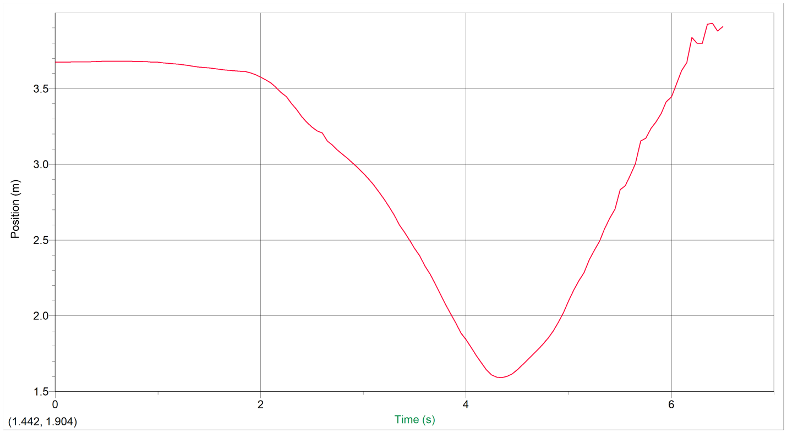
Analysis-

Data:
Sample Data
0 3.674 0.014 -0.016
0.05 3.674 0.014 -0.035
0.1 3.675 0.012 -0.056
0.15 3.676 0.007 -0.054
0.2 3.676 0.004 0.001
0.25 3.676 0.006 0.082
Sketched graph and work:
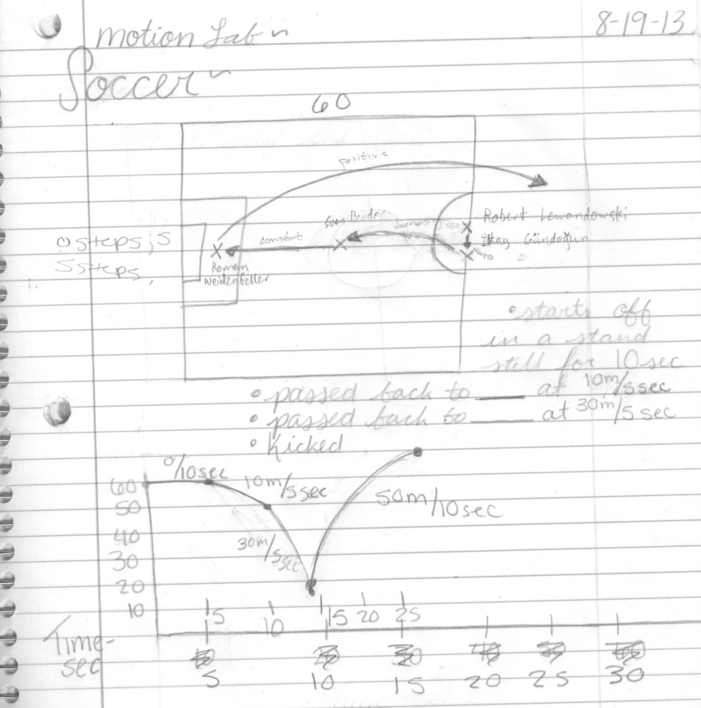
0.3 3.676 0.013 0.132
0.35 3.677 0.025 0.0
0.4 3.679 0.025 -0.069
0.45 3.68 0.014 -0.13
0.5 3.68 0.007 -0.119
0.55 3.68 0.002 -0.092
0.6 3.681 -0.003 -0.06

Conclusion-
- Overall, the outcome of the lab was the result in a graph of the soccer balls position vs. time as it moves around the field to each of the players. The graph created by the motion detector shows a negative slope. Then once it’s reached the minimum then there’s a steep increase reaching the balls maximum velocity. The sketched graph and the motion detector created graph look very similar except for the point at the very bottom. The motion detector graph does not have the point at the bottom because the ball is constantly in motion and in order to switch to the positive motion, you have to stop or slow down and go backwards even if it’s slighter than a second. The sketched graph does have the point at the bottom presenting that the ball never stops before changing directions which is impossible. The motion detector graph is much more accurate compared to the drawn out graph. Since completing this lab I am now more familiar with the instruments that we used such as the Lab Quest and the motion detector.

